You Can Measure Weather Reading

Weather is so interesting! There are so many different types of weather. How do we keep track of them all? It’s actually quite easy. Scientists use tools called instruments to measure weather! Like weather, there are many different types of instruments to measure different types of weather. Let’s begin by learning about these instruments.
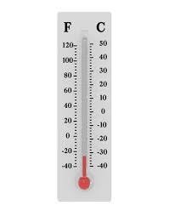
The thermometer is a very important instrument used to measure weather. First, remember that temperature is the hotness of something. Thermometers measure the temperature of anything, including water and the outdoors. They are useful when you want to know how hot or cold it is outside. When the thermometer measures a high temperature, you will know that it might be a good idea to wear shorts and eat ice cream. However, when the thermometer measures a low temperature, it might be a good idea to wear a jacket and drink hot soup. Thermometers are useful instruments!

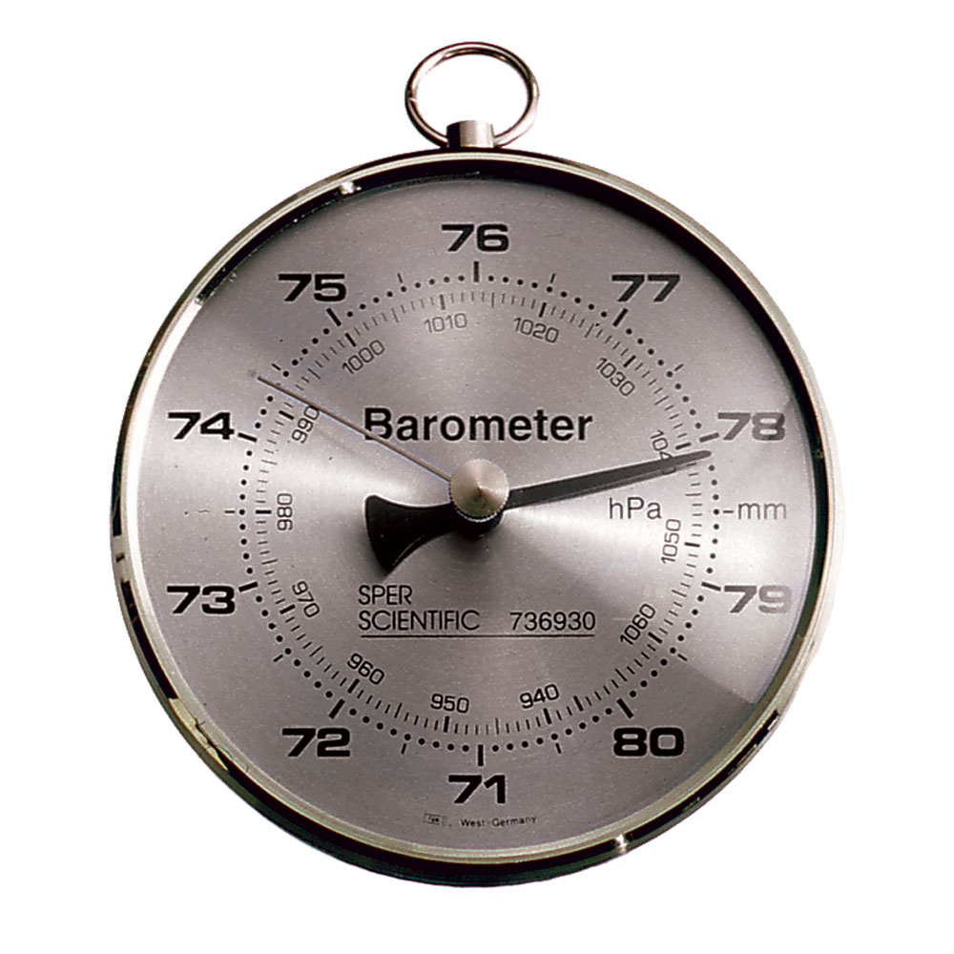
The barometer is also a very important instrument. We must first know that air pressure is the amount of force air pushes on Earth. A barometer measures the air pressure of the place that you are in. When you go up to the mountains, the barometer will measure that the air pressure is low. When you go down to oceans, the barometer will measure that the air pressure is high. This is important to know because the air pressure of an area will tell you if it will rain or be windy.

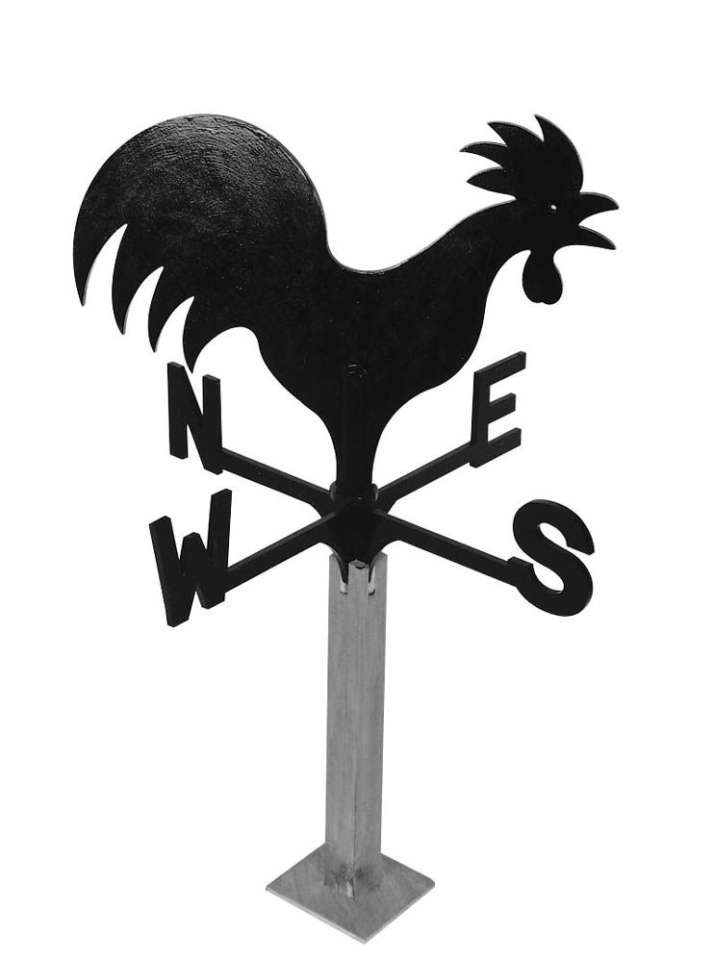
The wind vane is a useful instrument used to measure the direction of the wind. The wind vane works by having the top spin and point to North, South, East, or West. Whichever direction the top points to is where the wind is headed! This is important for farmers to know because knowing the wind direction means knowing the weather.

