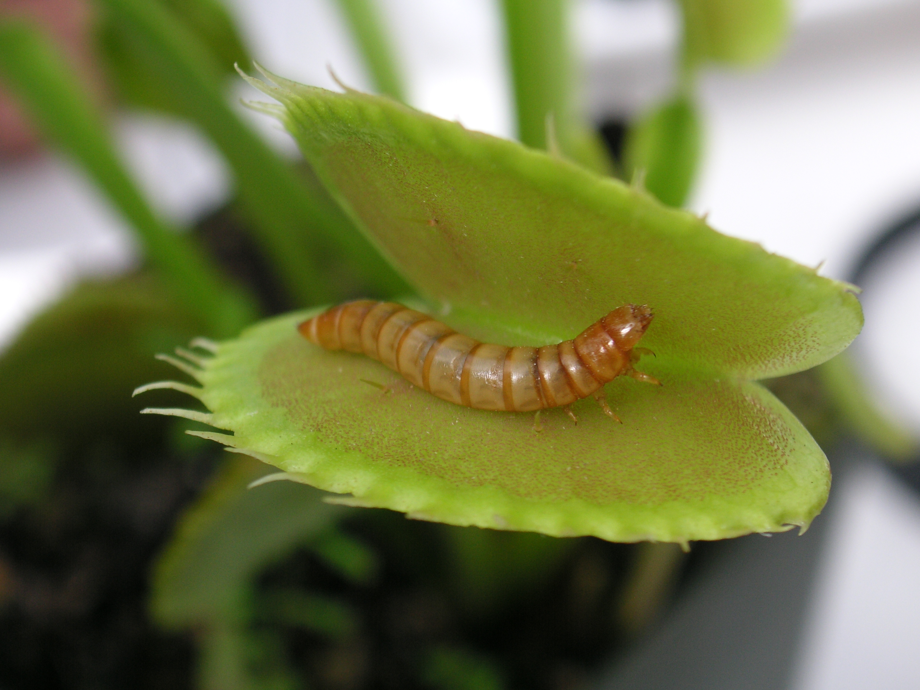
The Venus Fly Trap

The Venus Fly Trap is an
amazing plant. It is just like
any other plant, but it eats insects! Like other plants, the Venus Fly Trap needs a lot of sunlight, at least 4 hours a day, and a lot of water. They get sunlight with their leaves and need water to use photosynthesis for food.
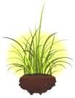

The only difference from the Venus Fly Trap with other plants is that it does not need soil that has a lot of nutrients. The Venus Fly Trap gets all its nutrients from eating insects. So they are really good at getting rid of flies and spiders!

Created by Kristine Maw

