NAME _______________
Quiz 1 Matter
Match these Terms
1 | Atom | A | A chart that shows all the elements known to man
2 | Molecule | B | an atom that is defined by the number of protons they possess.
3 | Compound | C | a group of atoms bonded together
4 | Periodic Table | D | Unit to measure mass
5 | Grams | E | the smallest particle of a substance that can exist by itself
6 | Matter | F | Anything that takes up space
7 | Element | G | molecule that has two or more elements

1 E
2 C
3 G
4 A
5 D
6 F
7 B

Label these parts
ELECTRON PROTON NUCLEUS NEUTRONS

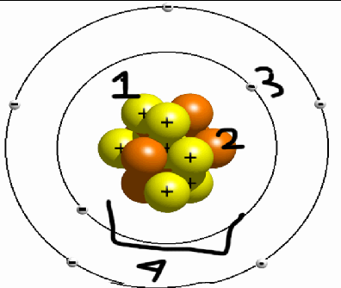
1 PROTON 2 NUCLEUS

3 ELECTRONS 4 NUCLEUS

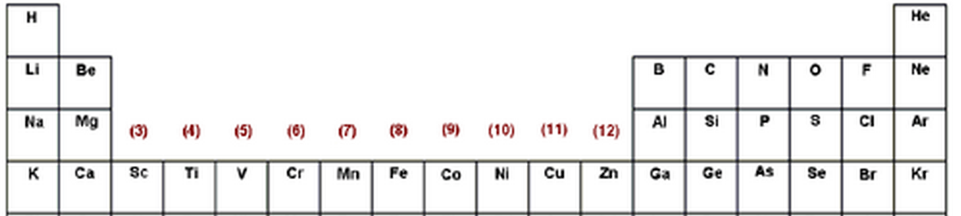

Using the diagram above. Tell me what element has the said amount of protons (use the short names in the diagram)

1) 4 protons BE
2) 6 protons C
3) 1 protons H
4) 9 protons F
5) 15 protons P

Multiple Choice
1. What is mass measured by?
a. grams
b. kilograms
c. centimeters
2. What is too small to be seen by the human eye?
a. molecules
b. atoms
c. protons
3. How many grams equal a kilogram?
a. 1000
b. 5000
c. 4000
4. What makes up an atom?
a. protons
b. proton and neutrons
c. protons, neutrons, and electrons
5. What is the nucleus made out of?
a. proton
b. neutron
c. proton and neutron
6. What has a certain amount of protons?
a. element
b. atom
c. nucleus
7. What is a molecule with two or more elements?
a. atom
b. proton
c. compound

