NAME _______________
FINAL
Describe three properties for each substance
- Wood
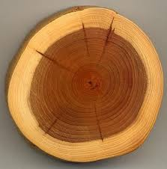

Brown
Flammable
Non conductible
Answers may very

- Plastic
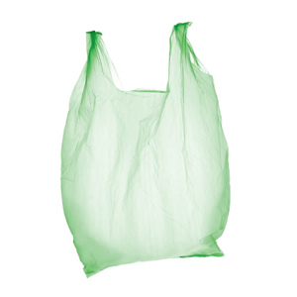
Opaque
Bendable
Non Conductible
Answers may very

- Metal
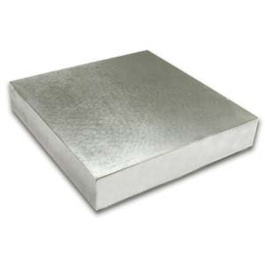
Hard
Conducible
Heat can transfer
Answers may very

Define these properties
- Size – how the matter looks
- Flammability – how easy the matter burns
- Magnetism - how does the matter attract metal
- Density - how compact the matter is
- Solubility – how easy the matter dissolves

Name three properties of matter other than the ones listed above
_______________
_______________
_______________

Answers may very

What is the formula for calculating Density?

D = M/V
How much grams are in
a) 13 kilograms 13000
b) 3 kilograms 3000
c) 8 kilograms 8000

Fill in the Blank
Solid | --> | Gas | dwdw
Liquid | --> | Solid
Gas | --> | Solid
Gas | --> | Liquid
Solid | --> | Liquid
Liquid | --> | Gas

Sublimation
Freezing
Deposition
Condensation
Melting
Vaporization
Label these parts
ELECTRON PROTON NUCLEUS NEUTRONS
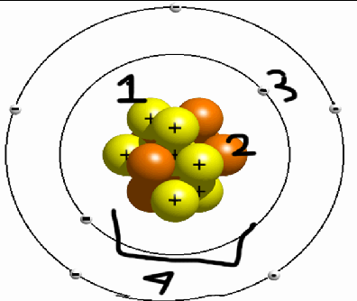

1 PROTON
2 NEUTRONS
3 ELECTRONS
4 NUCLEUS

Tell what is the Solvent and The Solute in each solution.

Saltwater SOLVNET – WATER SOLUTE – SALT
Chocolate milk SOLVENT – MILK SOLUTE - CHOCOLATE
Vinegar SOLVENT- WATER SOLUTE - - ACEDIC ACID
Lemonade SOLVENT- WATER SOLUTE - LEMON

Mix and Match
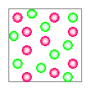 Solid
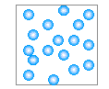 Gas
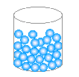 Liquid
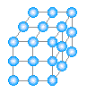 Plasma

1 | Matter | a | the measurement for matter
2 | Mass | b | the state in which matter is in
3 | Sublimation | c | a chart that shows all elements
4 | Absolute Zero | d | removing big items from a substance
5 | Filtering | e | the amount of matter in a substance
6 | Phase | f | the temperature at which matter cannot move
7 | Periodic Table | g | a group of atoms
8 | Molecule | h | having more than one element
9 | Compound | i | defined by protons
10 | Element | j | smallest compound that is made of a proton, electron and neutrons
11 | Atom | k | Anything that is made of space
12 | Grams | l | the point in which matter becomes a liquid
13 | Boiling Point | m | solid → gas

1) K 2) E 3) M 4) F 5) D 6) B 7) C 8) G

9) H 10) I 11) J 12) A 13) L

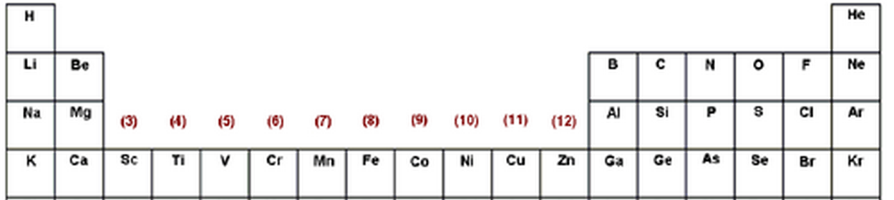Using the diagram above. Tell me what element has the said amount of protons (use the short names in the diagram)

1) 3 protons LI
2) 10 protons NE
3) 2 protons HE
4) 13 protons AL
5) 5 protons B

What does adding heat cause particles and atoms in matter to vibrate faster?
Adding heat gives energy for the atoms so that they can use that energy to vibrate faster.

What is the difference between a physical change and a chemical change?

Physical Change changes how the matter looks but not the composition while chemical change changes the compositions.

Give an example of
Liquid
Gas
Solid
Evaporation
Melting
Freezing
Compound
Solution
Mixture

Answers may Very

Tell whether this is a chemical change or a physical change
- Cutting P
- Rusting C
- Cooking C
- Coloring P
- Melting P
- Exploding C
- Breaking P
- Spoiling C
- Burning C
- Crushing P

