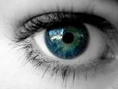

1) Eyesight

a) What are lens?

b) Where are the lens located in the eye?

c) What controls the amount of light that goes into the eye?

d) Why is the iris different from people to people?

e) What direction is the image when it goes into our eye?

f) The eye is connected to what part of the brain?

