NAME:___________
Mining QUIZ

1. What is a mine?

_________________________________________________________

_________________________________________________________

2. What do people mine for in this picture?
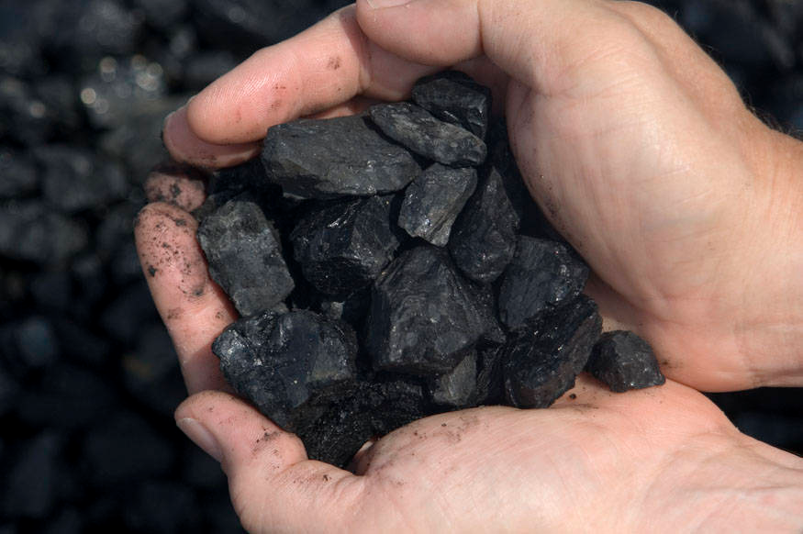

____________

3. How long does it take to make coal? Circle one.
a. 5 years b. 10 years c. 100 years d. millions of years

4. What does coal make? Use the pictures as hints!

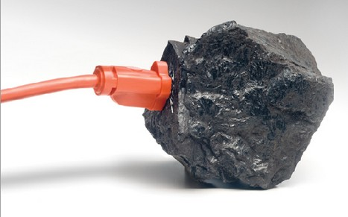

____________

5. _______ are used to mine but can be dangerous! Circle one. HINT: This goes BOOM!!!!

a. Water Power b. Explosives c. Shovels d. Big Machines

6. These vehicles are used to transport mining rubble. Circle one.
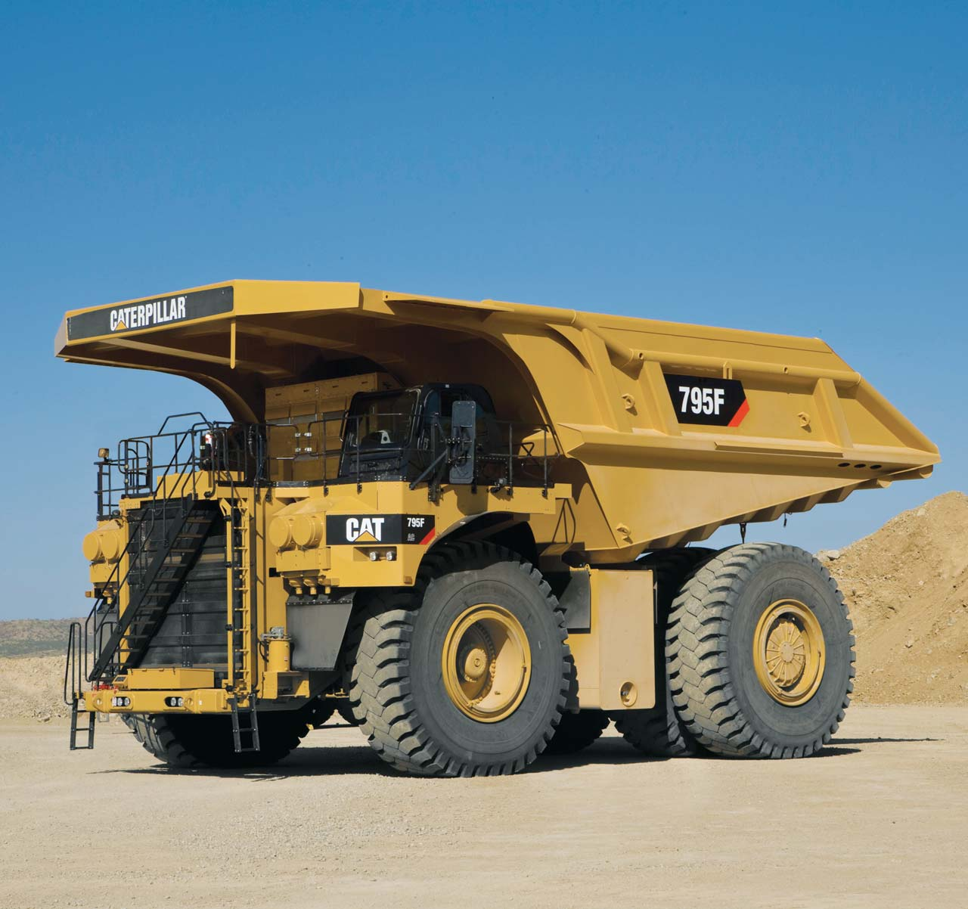

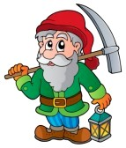
a. Cars b. Bicycles c. Big Trucks d. Trains

7. Which of following do we mine for? Circle one.
a. Diamonds
b. Gold
c. Gems
d. Coal
e. ALL of the above

8. What do you call people who mine for stuff? Circle one.
a. Treasure Hunters
b. Diggers
c. Miners
d. Builders

9. We can mine underground by digging big tunnels. True or False? Circle one.
TRUE FALSE

10. Mining can destroy beautiful forests, lakes, and mountains. True or False? Circle one.
TRUE FALSE

